Test cases:
- Unconstrained Branin
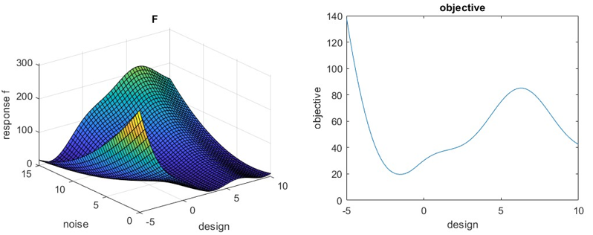

Unconstrained optimum of this example:
with objective function $f=μ_{f}+σ_{f}$ is at: $x=-1.5343$ with $Obj=19.6188$
with objective function $f=μ_{f}+{3σ}_{f}$ is at: $x=-1.1331$ with $Obj=28.1851$
with objective function $f=μ_{f}+{6σ}_{f}$ is at: $x=-1.0088$ with $Obj=39.0749$

This is the ground truth optimum using the actual function (not using a metamodel created by DOE)

- Branin with one inequality constraint
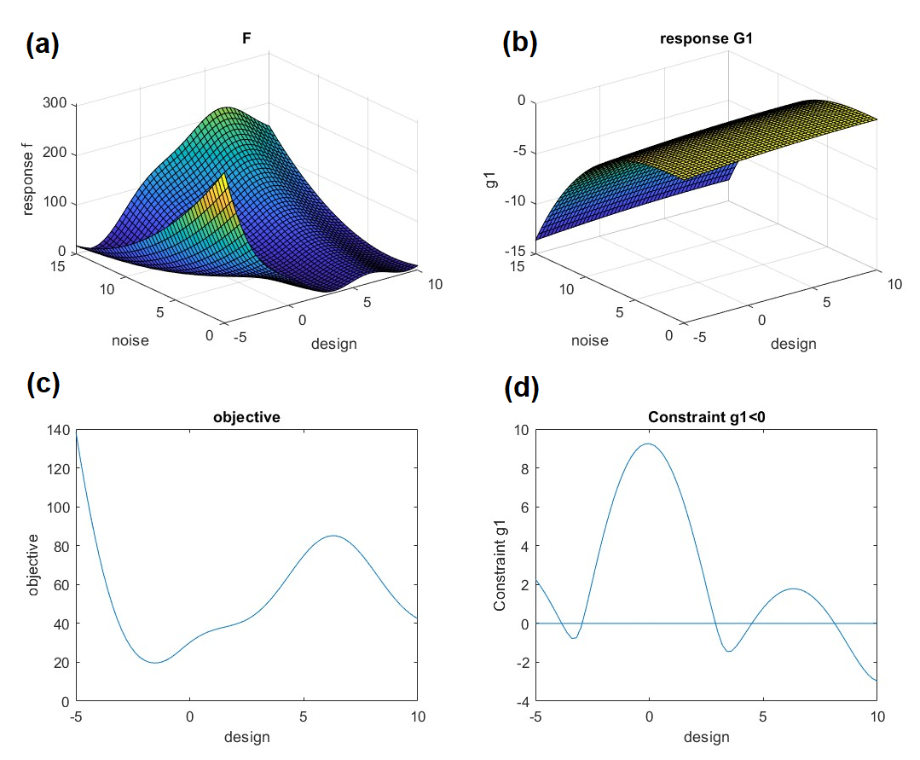
Figure 1: Branin function (a) and a constraint (b), objective function $μ_{f}+σ_{f}$ (c) and constraint function $μ_{g}+3σ_{g}-val≤0$ (d)
$$f\left(x,n\right)={\left(n-\frac{5}{4π^{2}}x^{2}+\frac{5}{π}x-6\right)}^{2}+10\left(1-\frac{1}{8π}\right)\cos\left(x\right)+10$$
$$g\left(x,n\right)=\frac{1}{100}{(\left(x-9\right)}^{2}+n^{3})\cos\left(\frac{xn}{24}\right)-5≤0$$

The ground truth optimum using the actual function (not using a metamodel created by DOE) is:
With objective function $μ_{f}+σ_{f}$ (c) and constraint function $μ_{g}+3σ_{g}-val≤0$
at $x=-2.9503$ with $obj=35.7247$
With objective function $μ_{f}+{3σ}_{f}$ (c) and constraint function $μ_{g}+3σ_{g}-val≤0$
at $x=-2.9503$ with $obj=$63.8640

(x=2.8981, obj=45.0198 is a local optimum which is not a correct answer)
HARTMANN 6-DIMENSIONAL FUNCTION with no inequality constraint

Unconstrained
Hartmann has 6 input variables with 4 design and 2 noise.
Ranges of all variables are 0 and 1 therefore for noise mean=0.5 and st-dev=0.5/3=0.1666

DesignVar1 | 0 | 1
DesignVar2 | 0 | 1
DesignVar3 | 0 | 1
DesignVar4 | 0 | 1
NoiseVar1 | 0.5 | 0.166
NoiseVar2 | 0.5 | 0.166

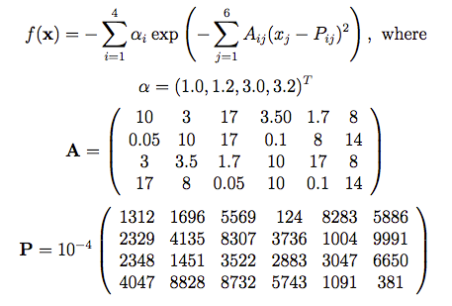

The ground truth optimum using the actual objective function (not using a metamodel created by DOE) with objective function $μ_{f}+σ_{f}$ is :
$$x=0.1426 0.1640 0.5494 0.1588 obj= -1.7292$$
with objective function $μ_{f}+{3σ}_{f}$ is :
$$x=0.2455 0.9296 0.5756 0.1053 obj=-1.3509$$
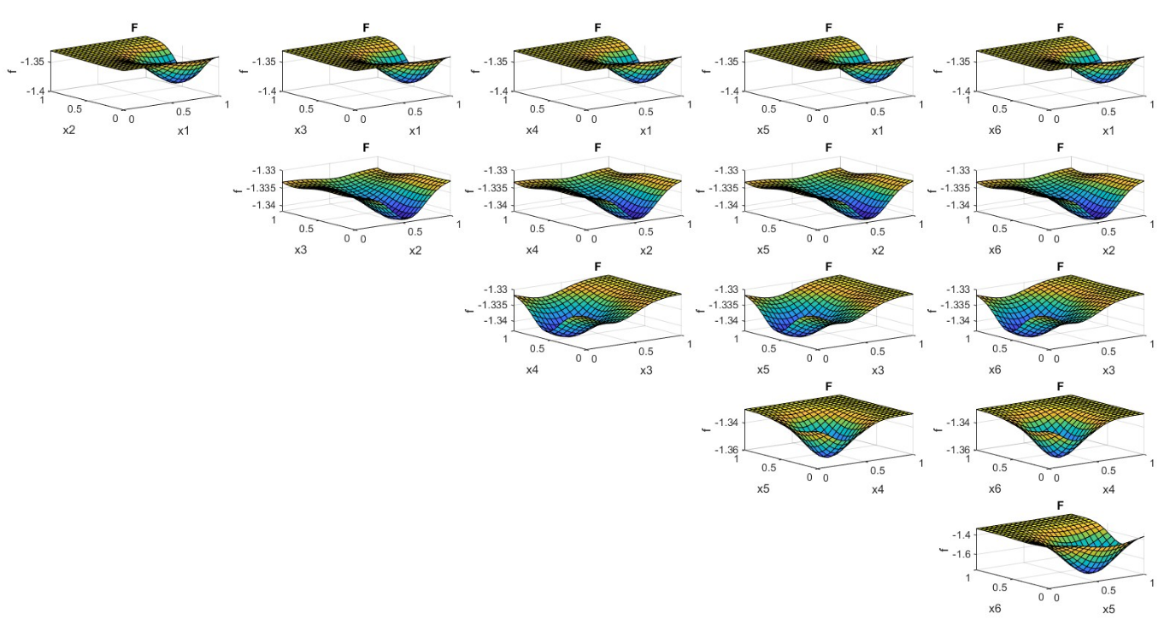
Figure 2: cross sections of Hartmann function

- HARTMANN 6-DIMENSIONAL FUNCTION with one inequality constraint
Modified griewank function is used as a constraint:
$$f\left(x\right)=a*\left(\sum_{i=1}^{d}{\frac{x_{i}^{2}}{4000}-\prod_{i=1}^{d}{\cos\left(\frac{x_{i}}{\sqrt{i}}\right)}}+1\right)+b (a=9, b=1)$$
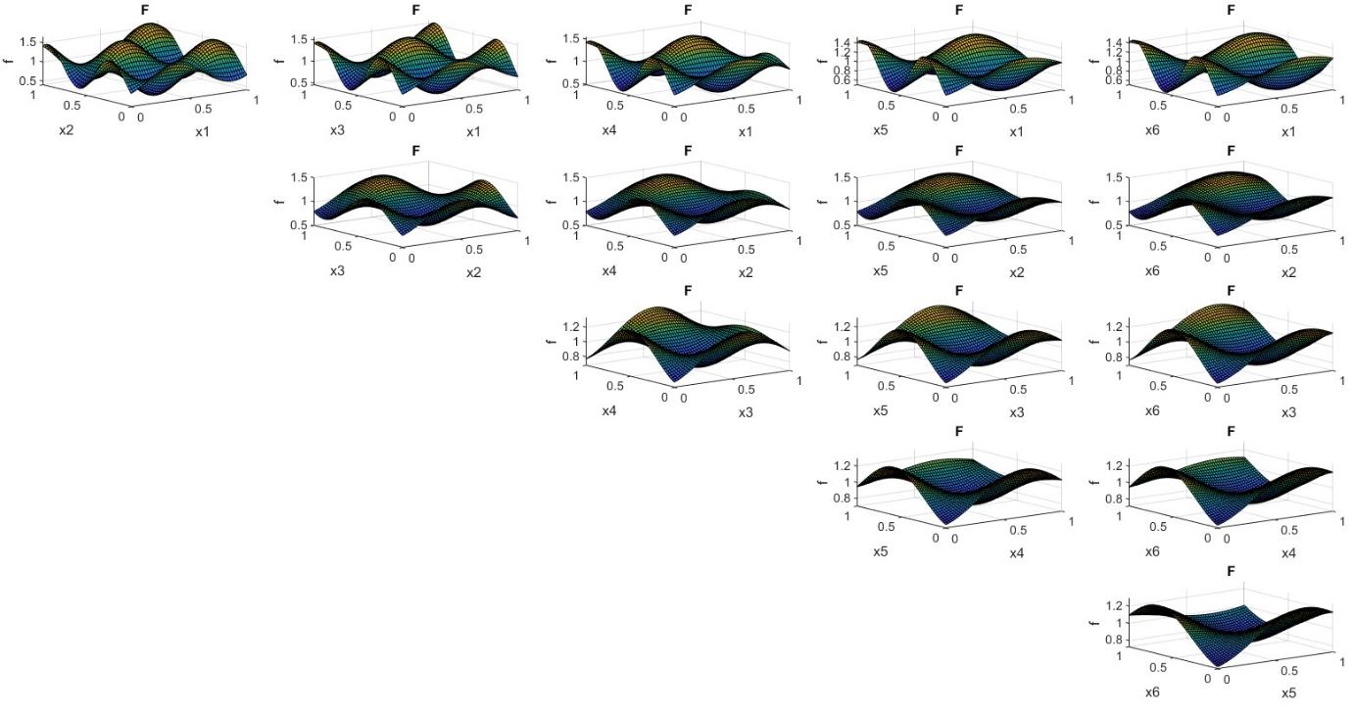
Figure 2: cross sections of griewank function with _9_1 scaling and shift

The ground truth optimum using the actual function (not using a metamodel created by DOE) is:

Objective is $μ_{f}+σ_{f}$ and constraint function is $μ_{g}+3σ_{g}≤val$ val=0.05
x= 0.1426 0.1640 0.5494 0.1587 obj= -1.7308

Objective is $μ_{f}+{3σ}_{f}$ and constraint function is $μ_{g}+3σ_{g}-val≤0$ val=0.05
$$x=0.0000 0.0000 0.3023 0.9215 obj=-1.32$$

- HARTMANN 6-DIMENSIONAL FUNCTION with two inequality constraint
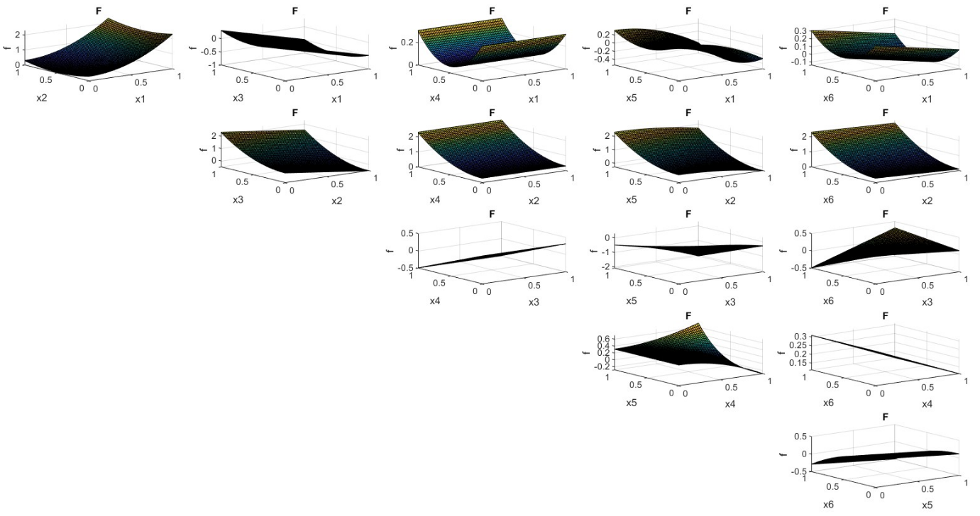
Figure 2: cross sections of g2 constraint function

$$g2\left(x_{1},…,x_{6}\right)={\left(x_{1}-0.5\right)}^{2}+\left(2x_{2}^{2}-0.2\right)-{(x}_{3}x_{5}-0.1)+\left(x_{4}^{3}-0.6\right)x_{5}^{2}+\left(x_{3}-0.2\right)\left(x_{6}-0.8\right)≤0.05$$

Value =0.05 must be entered separately (Not like the previous examples for which the value was 0)
The ground truth optimum using the actual function (not using a metamodel created by DOE) is:
Objective $μ_{f}+σ_{f}$ and constraint functions $μ_{g1}+3σ_{g1}≤0$ $μ_{g2}+3σ_{g2}≤val$ val=0.05
$x=0.2150 0.0887 0.5633 0.2076 obj=-1.6987$
Objective $μ_{f}+{3σ}_{f}$ and constraint functions $μ_{g1}+3σ_{g1}≤0$ $μ_{g2}+3σ_{g2}≤val$ val=0.05
$$x= 0.4054 0 0.6073 0.0000 obj=-1.20$$
Objective $μ_{f}+{3σ}_{f}$ and constraint functions $μ_{g1}+6σ_{g1}≤0$ $μ_{g2}+3σ_{g2}≤val$ val=0.05
$$x= 0.2817 0.1332 0.5307 0.0000 obj=-1.2327$$

https://www.sfu.ca/~ssurjano/hart6.html

